Function Module For Purchase Order Simple Code with Understanding Pic’s

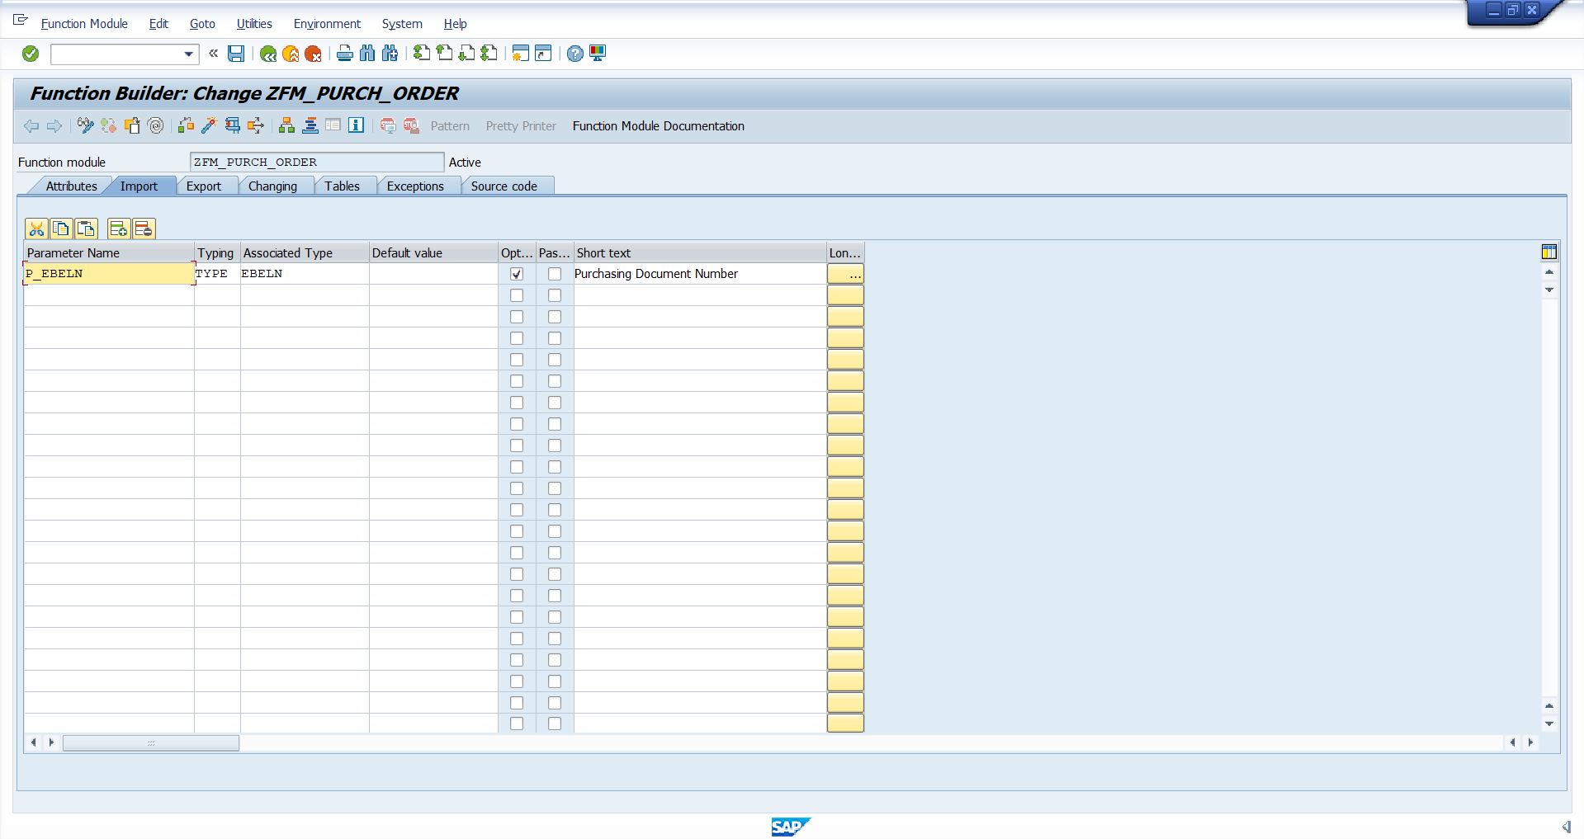
Importing Parameter

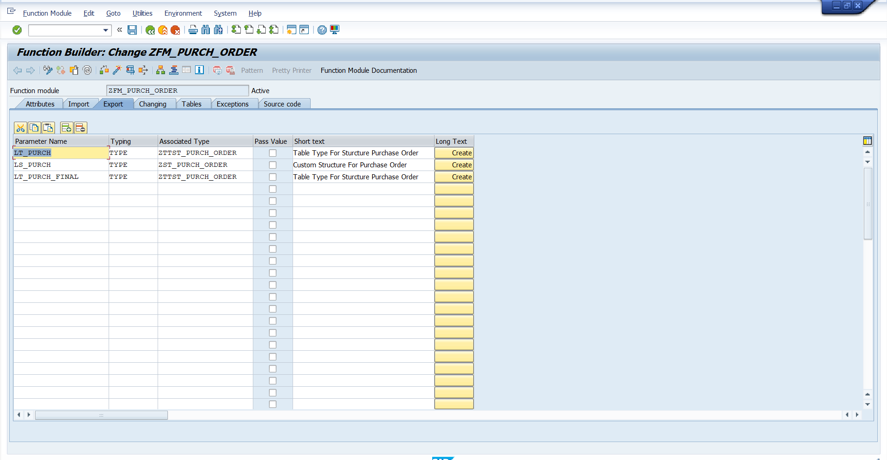
Exporting Parameter
When we given a Internal table in Function Module we have to give Table Type for the Internal table
And for Work Area we have to give a structure like (Global Structure)
Note: I created Custom Structure I give the to work Area and I created Table type for internal table.
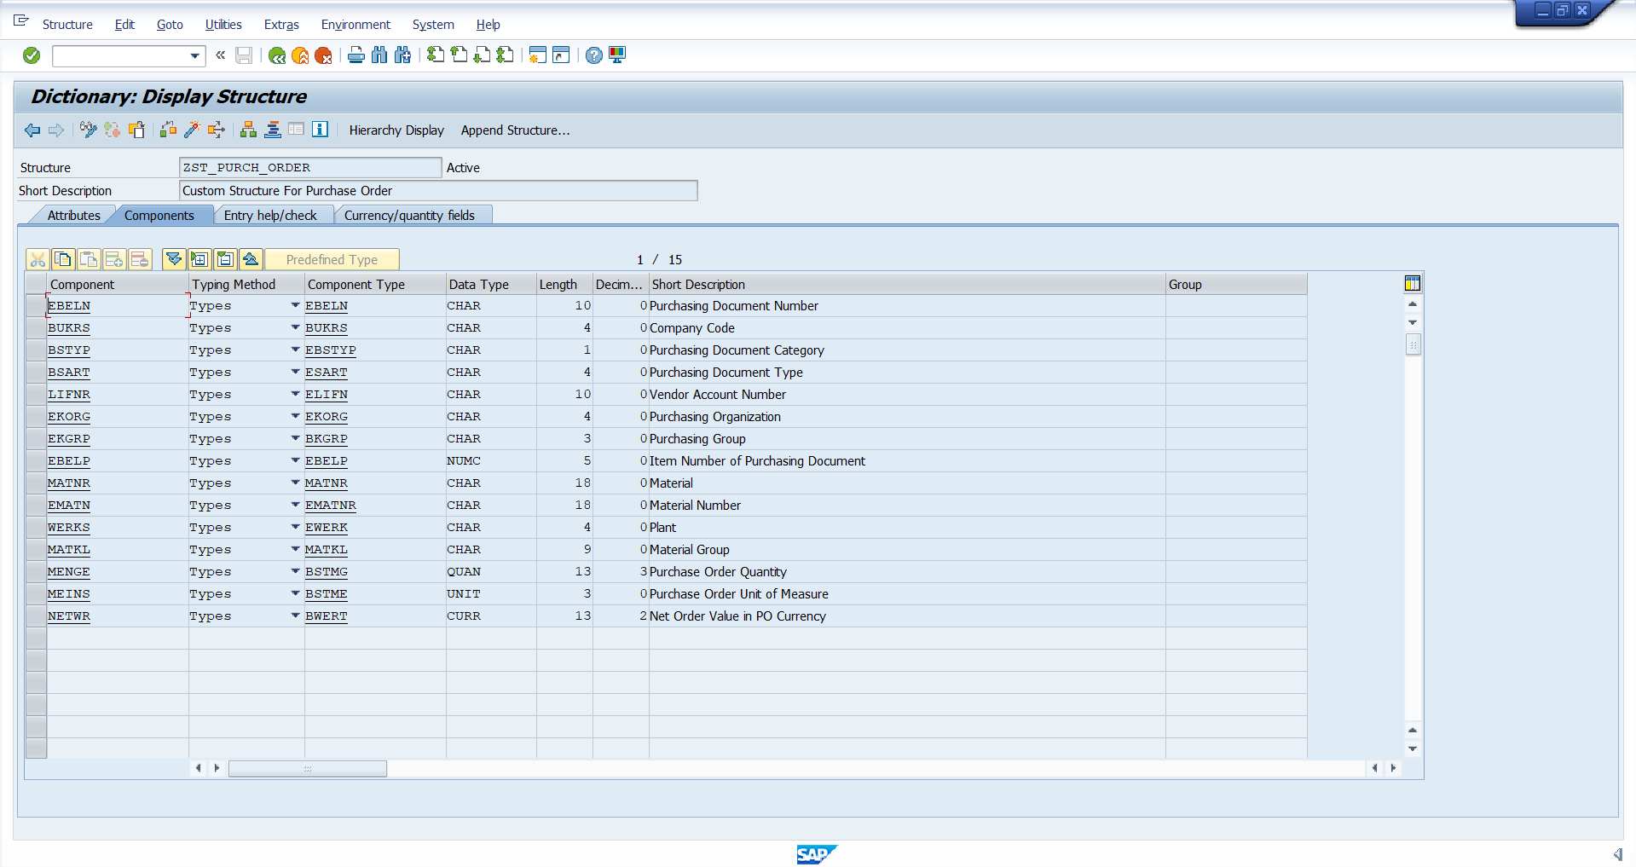
Custom Structure for the work area
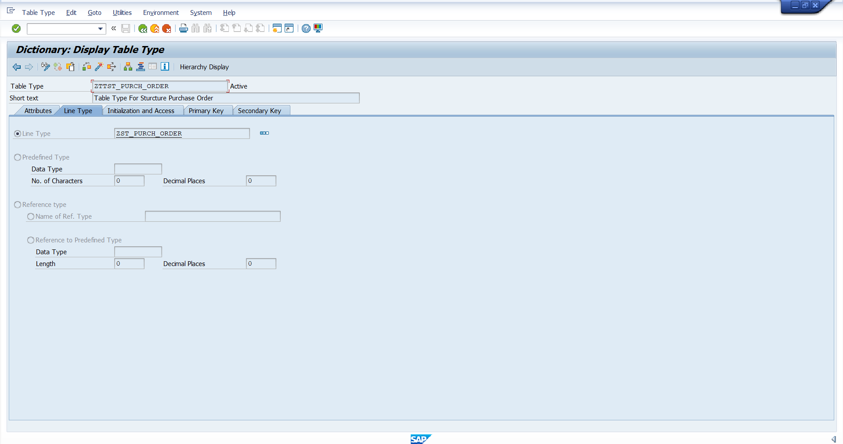
Structure Converted Into Table Type For the Internal Table

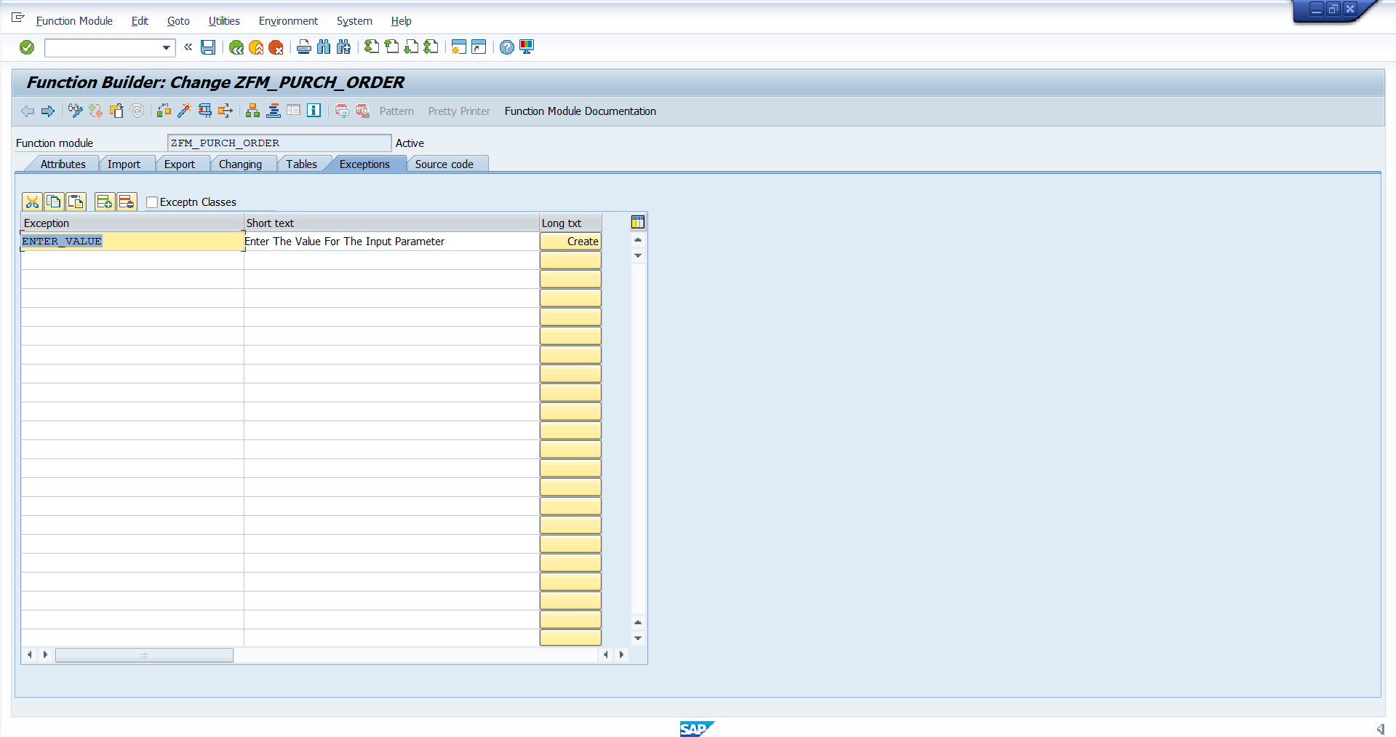 Exceptions for Error Handling

Source Code:
FUNCTION zfm_purch_order.
*"----------------------------------------------------------------------
*"*"Local Interface:
*" IMPORTING
*" REFERENCE(P_EBELN) TYPE EBELN OPTIONAL
*" EXPORTING
*" REFERENCE(LT_PURCH) TYPE ZTTST_PURCH_ORDER
*" REFERENCE(LS_PURCH) TYPE ZST_PURCH_ORDER
*" REFERENCE(LT_PURCH_FINAL) TYPE ZTTST_PURCH_ORDER
*" EXCEPTIONS
*" ENTER_VALUE
*"----------------------------------------------------------------------
IF P_EBELN IS INITIAL.
RAISE ENTER_VALUE.
ENDIF.
" This is a Select Statement to select the field form ekko & ekpo Table.
SELECT
a~ebeln
a~bukrs
a~bstyp
a~bsart
a~lifnr
a~ekorg
a~ekgrp
b~ebelp
b~matnr
b~ematn
b~werks
b~matkl
b~menge
b~meins
b~netwr
FROM ekko AS a INNER JOIN ekpo AS b ON a~ebeln = b~ebeln " Using Inner Join for to fetch the common data form ekko & ekpo both table.
INTO TABLE LT_PURCH " The processed data Insert to the (LT_PURCH) Internal Table.
WHERE a~ebeln = p_ebeln.

LOOP AT LT_PURCH INTO LS_PURCH. " Using Loop For Read the Record One by One .
IF LS_PURCH-MATNR IS INITIAL. " To Check Every Record as have the value for (MATNR) Field.
CONTINUE. " When the Record not have the value of (MATNR) Field it will skip that Record.
ENDIF.
APPEND LS_PURCH TO LT_PURCH_FINAL. " It will Append the reocrd one by one to the (LT_PURCH_FINAL) INTERNAL TABLE.
ENDLOOP.
IF LT_PURCH_FINAL IS INITIAL. " When the user Enter a purchase order Number but the Po Number does not have the value for (matnr)
MESSAGE : 'This Purchase order not have the value of MATNR' TYPE 'E'. " It will Through a Error Message.
ENDIF.
ENDFUNCTION.

